Meeting of the Site Representatives of the Brighton & Hove Allotment Federation

Brighthelm Centre on Wednesday 8th January 2014
6-30pm for 7-00pm start

AGENDA

- Chair Introduction and Welcome
Russ Howarth (Vice-chair BHAF) welcomed all present and passed around a sheet for attendees to sign, name and site. He outlined what was on the agenda and asked whether any site reps had any issues they would like to raise. We will finish at 9.00pm. The committee members introduced themselves.

Issues raised by site reps that they wanted to discuss:
- Date of start of inspections
- Problem of funding - Racehill

Present from BHAF Committee:

Allan Brown – Secretary
Mark Carroll – Publicity Officer
Anne Glow
Russ Howarth – Vice Chair
Steve Lucas

2. Apologies
BHAF COMMITTEE:
Emily Gardiner - Treasurer
Alan Phillips - Chair

SITE REPS
Granville Wilcock – Horsdean
Jane Griffin – Whitehawk Hill

- Minutes of the September Meeting
None – (minutes weren’t formally passed, an oversight on our part. But as no objections/ amendments were raised, we will assume the minutes of the previous meeting were agreed.

4. Matters Arising from those minutes
None

5. Governance
Russ Howarth explained how the new, proposed governance structure of the allotments would work.

(See Appendix 1 and 2)

Following the presentation, questions were asked by various ‘site reps’.

Guiseppina (Moulscoomb Estate) enquired as to who makes up the Liaison Group? How would site reps be informed of the various working groups or other ‘Interested Parties’. These groups would need to be invited.

Some existing ‘site reps’ didn’t like the terminology of ‘site steward’, some alternatives were offered.

Site Volunteer
Site Warden
Site Officer

Appointed Site Representative and Elected Site Representative? Why the word ‘Steward’ – RH replied that a non-elected site rep isn’t representative. Mark Carroll said that the term ‘site steward’ was used by the NSALG (National Society for Allotments and Leisure Gardens.

Are site rep elections annually too frequent?

Maureen (Moulscoomb Estate) was concerned that the timetable for the Allotment Strategy was too rushed and that sufficient time should be factored in to ensure that the wider allotment community had a say in the proposals.

Richard Howard (Moulscoomb Estate) expressed his dissatisfaction that as an elected Association Rep, he wasn’t afforded full committee status and was not currently invited to attend Liaison meetings.

6. Site Development Fund
Ron Nicholson (Racehill) outlined the frustrations they’ve experienced in trying to claim from the Development Fund - this refers to the request to have a rotavator for their site. (Please refer to previous Site Rep Meeting minutes for details on the BHAF Committee’s recommendations for how the development fund is proposed to be used/ allocated in the future.

Steve Lucas answered Ron’s query.

He had no recollection of having had said ‘yes’ to Ron. There were two requests from Racehill, one was for a strimmer and one was for a rotavator. The money for the strimmer was forwarded to Racehill, but the Federation has never bought a rotavator previously. The floor felt this was a personal issue that needed resolving at a private meeting between the Committee and Racehill site reps.

Russ Howarth referred everyone to the ‘Site Development Fund’ update that is on the BHAF website. (http://www.bhaf.org.uk/page_id__73_path__0p11p9p.aspx)
He outlined the key points:

Purpose
Access
Sustainability
Safety
Ownership
Storage
Insurance
Appropriate Use
Environmental Concerns

Jeff Woods (Ovingdean) felt they was pressurised into choosing the cheapest equipment and when it broke and they requested a replacement they were refused. He also explained that they’d had a number of requests turned down and was as a result reluctant to reapply. RH reassured the floor that it was always worth reapplying.

Tracy Llewllyn (Ovingdean) queried how the Federation could check whether all the required documentation/ assurances required from site reps making an application. Russ Howarth clarified that this process was based on trust but the Fedeeration had an obligation to set out these basic requirements

Andrew Amos (Roedale Valley) asked whether any left-over funds from the development fund could be used to mend power tools, rather than being reabsorbed. RH stressed it was a development fund, not a maintenance fund.

RH discussed the Fed’s idea of buying specific items – generators, post driver, mattock, step ladder with adjustable legs, apple press, wood chipper, hedge trimmer, rotavator etc .- that could be held centrally but borrowed by any site.

This idea was well received by the site reps. David Cooper wondered whether heavy equipment – possibly stored at Stanmer – could be dropped off by the maintenance team.

RH mentioned that a specific amount has been set aside from the development fund to buy a motion sensitive, infrared camera which will cost about £200. They will be moved around different sites. These could be used in conjunction with ‘fake CCTV’ cameras.

The other use of the development fund will be primarily to aid the formation of new allotment societies. The BHAF Federation has drawn up a budget predicated on these lines – please refer to BHAF Committee Meeting Minutes on BHAF website.

7. Night Time Site Patrolling
Steve Lucas introduced this agenda item. As a result of sites experiencing vandalism, Steve Lucas and Gary Johnson did a night-time patrol of Craven Vale, Whitehawk and Tenantry Down during July 2013. They demonstrated to themselves that it’s feasible and presents the most realistic way of protecting our sites from vandalism. He hoped that by floating this idea, other site reps and tenants would get involved. Steve Lucas has worked with PC Funnell and David Cooper about the correct protocol.

Ron Nicholson (Racehill) said that the night-time patrol had alerted the local PSCO Officer, so he hoped that if this was a regular event the relevant parties would be forewarned.

RH clarified that before undertaking night time patrols one would need to contact the police prior to doing a patrol. You would do it in groups of three and you’d need to have a mobile phone and you would not apprehend anyone, simply report all suspicious activity to the police. P, to ensure they didn’t do themselves an injury, patrollers would need to take high powered torches.

Melanie Mathews (Lower Roedale) asked for further clarification about the safety of doing patrol. SL reiterated that no-one should try to apprehend anyone.

Tracy Lllewllyn (Ovingdean) asked what number do you phone – 999? David Cooper clarified that they would simply call the incident number, which would have been set up prior to the patrol taking place.

The general feeling from the site reps that this idea was a non-starter. Andrew Amos – Roedale Valley said that as site reps they signed up to do administrative work, not put their lives on the line. MM (Lower Roedale) suggested that a group of people sitting together in a shed after dark, not moving about, would be a more realistic option.
Ron Nicholson (Racehill) hoped that the PCSO’s would be able to do more patrols as they are trained.

8. Strategy
This agenda item was largely discussed in the context of the proposed ‘governance’ recommendations .

9. Inspection Date.
David Cooper said that if the weather is mild we can start inspections in March. If reps could start making their first notes and submitting them to the office from the beginning in March, to be completed by the 31st March. This will be reviewed depending on the whether.

The AGM is on the 19th March 2014 – either at Brighthelm Centre or Patcham Community Centre.

9. Site News
No individual site news updates were shared, due to time constraints.

10. AOB
None

11. Date of Next Meeting
(Meeting ended at 9.00pm)

Appendix 1:
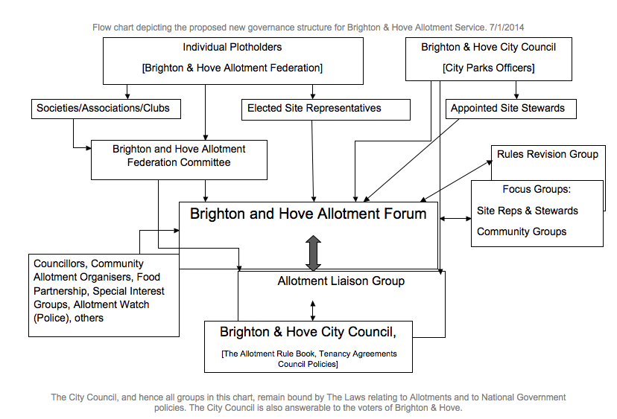

Appendix 2:

Notes on the proposed new governance structure.

- Individual Plotholders The primary route for individual plotholders to contribute to the governance structure is through the Federation, of which we are all members.
- Societies/Associations/Clubs The strategy will seek to encourage the development of organized groups of plotholders. The Federation should become more of an umbrella group for these organizations. They should be able to directly nominate members to the Committee. As the number of societies increases the committee could become unwieldy so the societies may need to elect/select committee members that serve more than one site. Societies, of course, Have a lot of their own work to do and may not have the desire or the capacity to contribute to the Federation Committee.
- Elected Site Representatives On an annual basis, there would be gate notices inviting nominations for site representatives. In practice we’d expect the notice to announce the existing site rep(s) and her/his/their willingness to continue. Probably most existing reps would be re-elected unopposed. Societies (where they exist) would organize these elections. Where there is no society the Council Officers and Federation Committee would organize this.
- Appointed site stewards As an interim measure existing “site reps”, or (on sites where there are no nominations) people directly approached by the Allotment Officer, may take/carry on duties of site representatives without the election process.
- BH Allotment Federation Committee: The Federation was originally seen as an umbrella body for site organizations. (Hence the proposed appointment/ selection/ election of Society Committee Members). There is nothing to prevent a site representative or site steward from standing for a position on the committee. Possibly more should be done to open nominations before and outside of the Annual General Meeting, although voting will have to continue to be at the AGM.
- BH Allotment Forum This effectively replaces the “Site Reps Meeting”. Societies could send representatives directly. Other interested parties could attend. Site representatives and stewards would be expected to attend. The Federation Committee would continue to host the meetings. Council officers and some councilors may choose to attend. The forum has a consultative role. Its agenda would include “Items to be submitted to the Liaison Group” and “Reports from the Liaison Group”. The cycle of meetings would be arranged so that issues and concerns raised in the forum could be discussed by the Committee before being raised at the Liaison Group. The Liaison Group would then report back to the forum.
- Focus Groups: At the “site reps consultative focus group” there was a clear feeling that small groups of site reps could benefit from opportunities to discuss their concerns. There is also a (perceived) under-representation of women in the current membership of society and federation committees. There may be a call for “Parent Plotholders”, “Older Plotholders” or other interest based focus groups. These would be informal sub-groups of the Forum and could attend and raise issues there.
- Rules Revision Individual plotholders, site representatives and stewards, society committees and others may find problems with the existing and future Allotment Rules. The Rules are set by the Council (elected members not officers) and cannot be changed without formal procedure. However the Council is committed to user consultation and a regular (possibly annual) Rules Revision group could discuss any problems, bring them to the Forum for consultation, and forward them to the Council (via it’s committee structure) for occasional amendment/clarification.
- Allotment Liaison Group The existing group is attended by Committee members, a designated Councilor and Council Officers. It has a fairly practical focus and seeks to make arrangements for improvements in the delivery of maintenance, inspections, site security, lettings procedures,evictions and so on. Under the new structure it would effectively become the executive group for the Forum. It would listen to issues raised at the Forum and try to address them, reporting back to the Forum on the actions it has taken or proposes to take. The Federation Committee is keen to maintain a role as the filter for contributions to the Liaison Group. (It is of little use either to plotholders or the Council if opposing views are presented to this group as having equal strength). The Committee seeks to come to a consensus taking into account the range of plotholder views and presenting a united front. Sometimes this may not be convenient for the council. The Committee does not want a situation where some plotholders interests can be ignored because the council have chosen to support one set of opinions over another.
- B&H City Council The Council own the land. They are responsible to the Government for fulfilling their duties under the Allotments Act, and to their electorate for the running of the City. This proposed Governance structure seeks to improve service user communication with the Council. The development of Societies and Associations, coupled with changes to the role of Site Representatives could improve the service without (in the longer term) involving extra cost. Nonetheless the structure recognizes that the responsibility, and therefore the control, lies with the Council.

