Meeting of the Site Representatives of the Brighton & Hove Allotment Federation

Patcham Community Centre on Wednesday 19^{h} June 2013 at 6-30pm
for 7-00pm start ( Tea and Coffee available )

AGENDA

- Chair Introduction and Welcome
Steve Lucas chaired the meeting.

2. Apologies
BHAF COMMITTEE:
Emily Gardiner – Treasurer
Alan Phillips – Chairperson
Tania Johnson – Committee
Russ Howarth – Vice-chair
Simon Powell - Committee

SITE REPS
Steve Chapman – Chates Farm
Jeff Woods – Ovingdean
Naomi Woods – Thompson Road
Granville Wilcock – Horsdean
Rob Froud – Tenantry Down
Jacob Nowinski – Whitehawk
David Cole – Weald
Vicky Heape – Lark Hill
David Medhurst – Hoggs Platt
John Low – Hildesland
Jane Hawkins – Craven Vale
Jane Child - Roedale

3. Minutes of the January Meeting
There were no hard copies of January’s Site Rep’s Meeting minutes available. (They are available for download on the BHAF website.)

4. Matters Arising from those minutes
None.

5. Allotment Watch
PCSO A.J. Funnel kindly attended the meeting along with two of her colleagues and handed out leaflets outlining the details of the Allotment Watch Scheme.

She stressed the importance of plot-holders ringing in allotment related crimes on the 101 number or reporting them online at www.sussex.police.uk. However, if you need an immediate response then phoning 999 is still the best way.
PCSOs will become more visible on your sites if you want them to. They are keen to engage with local communities and allotments are ‘communities within communities’. They will run ‘community engagement’ meetings/ workshops.
They can target patrols to specific times to be more visible. An email community messaging system has been set up for fast time distribution of relevant information.

Gerry Neville – Coldean, felt that a presence around school holidays was important.

PC Funnel said that shed break-ins are classed as burglary. At Racehill for example, which suffered from a spate of shed break-ins earlier in the year, they set up patrols that were visible both day and night for about a week.

Everything needs to be reported, as without a crime number the police will not be able to act on the information.

Various site reps reported that tenants seem reluctant to report crimes, however if they did so, the crimes (however minor) will be logged. In fact it’s preferable if the individual tenants affected, all ring in their crimes individually as a site rep ringing in on behalf of all their tenants would only be logged once. It really does pay to report crimes, however small.

PC Funnel reassured Steve from Eastbrooke Farm that even though the PCSO for Eastbrooke is in Adur, the 101 number will get his reports to the right jurisdiction.

Melanie Matthews said that at Lower Roedale, the site is bounded on one side by houses. She enquired as to what could be done to engage with them as some of the residents also have allotments, so have a vested interest in reporting suspicious activity. She also enquired as to what could be done if a house is identified as allowing people access to the allotments through their property. PC Funnel agreed that targeting these houses with leaflets would be a good thing to do.

The state of fences on allotments in general was raised. David Cooper said that the funds for improving fences on a large scale were just not available. Gary Johnson mentioned barbed wire and anti-climb paint, both of which are not allowed by BHCC. David Cooper said he would discuss this further with other council departments, but there are strict guidelines on what sorts of deterrents allotment sites could legally use.

PC Funnel requested that all the ideas that were discussed this evening are emailed to her so she can act on them. Keeping lines of enquiry open – like reporting there’s a house that may have witnessed something – is important. Without an open line of enquiry the reports are shelved as there is no information on which to take forward the report.

6. Forming Site Associations
Allan Brown gave a brief outline of the Fed’s commitment to encourage sites to create Allotment Associations.

At the 2012 AGM a ‘Special Motion’ was initiated calling on the Fed to improve it’s representation. The BHAF feel that the primary way we can improve representation is to encourage the creation of more Associations. The BHAF constitution was amended at the 2013 AGM and an elected Association Delegate/ Rep can now attend BHAF Committee meetings with full voting rights. We already have an Association Rep, Richard Howard from Moulscoomb Estate, who’s attended a Committee meeting and we are keen for other sites to do likewise.

Being in an association has many positive aspects. For example, associations can join the National Society (NSALG) that gives you access to legal advice and support and not least, you can buy supplies from them wholesale, saving over half the price on seeds and other items. Associations can also take an active role in electing your site reps. They can also apply for funding from various bodies. An Association creates a community on a site, which in turn helps with security and the general well being of the site. Associations can open little seed shops and tea huts on saturdays.. They can also help with general maintenance around the site, improving the site for everyone.

David Cooper mentioned that Associations may be able to get insurance cover that would cover their members. (It was pointed out that whilst they could get insurance for allotment shops/ tea-huts etc. insuring individual plot-holders was prohibitively expensive.)

http://www.bhaf.org.uk/page_id__549_path__.aspx

The BHAF website has several downloadable examples of various constitutions – from the simplest to the more complex – and these can be used/ amended in order to get an Association up and running.

Amos said that RAGS (a very vibrant and well run Allotment Association) would be keen to help other sites to set up their fledgling Associations and could act as a mentor.

David Cooper said the Council are also keen to help sites set up Associations and where there is an interest could help with organising group emails to tenants etc.

There was some discussion about the number of people that are needed to make an association – a quorum. Jane (Craven Vale) was concerned that small cliques may be formed and call themselves Associations, but in reality do not actually represent plot-holders as a whole. This was a good point and the Fed will ensure that any Association sending delegates to attend Committee Meetings, will have to provide evidence that they are democratically run and meet a basic set of standards that will be formulated.

Gerry Neville (Coldean) said that in addition to Associations, plot-holders need to be aware of the Fed. and the fact that all plot-holders in Brighton & Hove are members of BHAF. He suggested that the Fed put up posters on gates, informing people of the fact.

Steve (Eastbrook Farm) and Amos (Roedale Valley) spoke very positively about the benefits of Associations and how they work on their respective sites. Steve stressed that no-one on site has to be a member of an Association, but without the Association they wouldn’t be able to organise BBQ’s, etc. Associations are great way to create a sense of community on site.

This is a long term vision/ goal but we are very pleased that Moulscoomb Estate have responded and led the way in having an Association Rep attend Committee Meetings.

7. Weald ‘Traffic Light System’ and wider general discussion on local site autonomy vs agreed citywide inspection processes.

Following the discussion on forming Associations and the benefits to sites for having an Association, the issue of The Weald Association implementing their own monthly inspection process was looked at. The Weald ‘traffic light system’ has been discussed at both a Liaison Meeting and the last BHAF Committee Meeting. (See minutes for 11th June 2013- BHAF Committee Meeting.) Whilst the BHAF is keen to promote Associations and a greater degree of autonomy for sites, when it comes to inspection processes we feel that sites should adhere to agreed targets – ie. it was agreed at a site reps meeting last year that this year (2013) we would concentrate on the worst 10 – 15% of plots and ensure that those plot-holders that have let their plots fall into neglected state, be chased up and evicted where appropriate.
Because the Weald’s ‘traffic light system’ notices that were put up on the gates of the site on Council headed paper with the Allotment Officer’s signature at the bottom, it gave the impression this was a Council/ BHAF led initiative and as a result we’d received a number of complaints from worried Weald tenants. Whilst most agreed that the Weald site reps were meaning to act for the overall good of the site and their plot-holders, in this instance the initiative seemed confusing to members, and perceived by some to be too intrusive and stressful. Most present at the meeting agreed that monthly inspections were not conducive to what should be a leisurely pursuit. There was also concern that the pinning of either a red, yellow or green notice every month to your plot could be likened to a public shaming, and that any informal warning would be better done in private.
In addition, not all Weald tenants are members of the Weald Association and it has been pointed out that as a result any Association initiative could not be enforced on those that have had no democratic say on whether this is something they would like implemented on their site.
The BHAF is keen to encourage plot-holders to get more involved with their sites, via Associations and engaging with the BHAF in general. Whilst we agree that the worst tenants should be evicted, in order to give new keen growers an opportunity to work a plot, we do not believe that serving more notices than can be administered will achieve a better allotment service. We are committed to a policy of raising standards through support, encouragement and engagement.
A general discussion amongst site reps present supported the BHAF’s position. Unfortunately, no Weald site reps were present to put their side of the argument forward. At the time of the meeting, the Weald ‘traffic light system’ notices were still up on the gate, despite being told by the Allotment Officer, some weeks ago, that they should be taken down.

Ron Nicholson (Racehill) said that if someone approached Pete Ferris with any allotment related trouble he was certain Pete would be willing to help. This was seconded by another site rep. It should be recorded that this issue was raised because of letters received by the BHAF from plot holders at the Weald and is about the nature of the notices and nothing to do with the site reps individually.

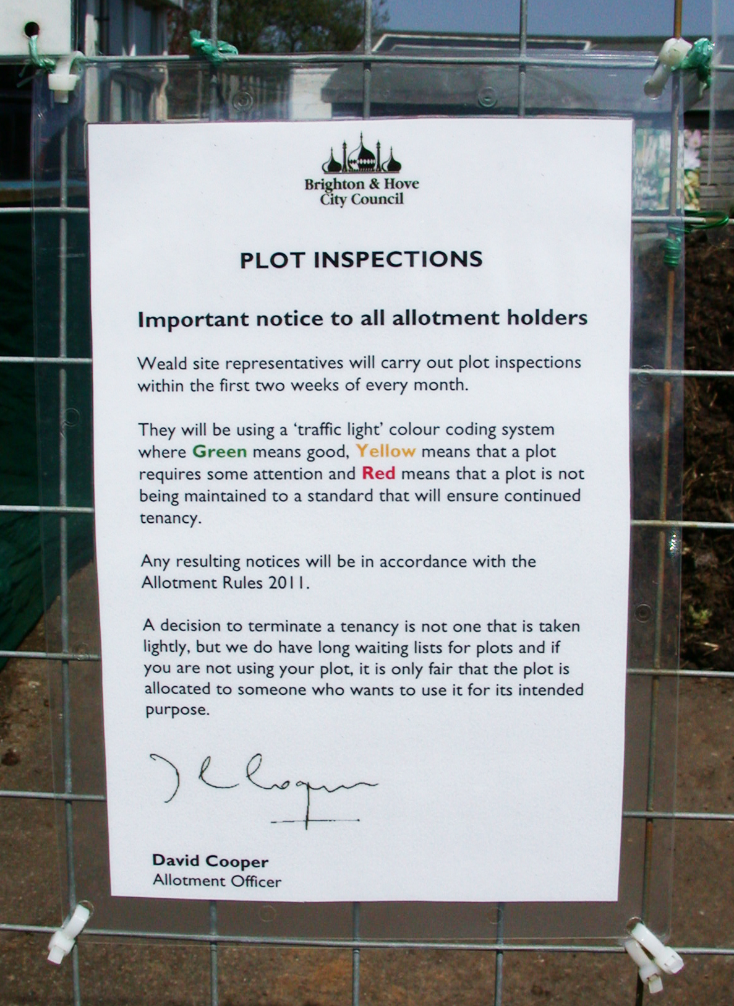

8. Inspection of Community Sites

In terms of community sites, it was agreed by DC and site reps that the inspection process for individual and community plots is the same. However MM highlighted there are examples where there attenuating circumstances. (ie. limited mobility beds.)

9. Strategy Update.
There was nothing of substance to discuss and due to time constraints this topic was passed over.

10. Allotments Officer. David Cooper
David Cooper explained that we are in the middle of inspection process. DC thanked site reps for their good work and clarified that we are now largely in the re-inspection stage and site reps have largely concentrated on the worst 10%, as agreed by site reps last year. The new inspection system, from an administrative point of view, is working very well. There have been very few letters of complaint which is a good indicator.

Site reps are welcome to join DC on the re-inspections as this has worked well in the past.

Melanie Matthews explained that the Fed and David Cooper have re-drafted the notice letters that are sent to tenants and they now read in a much less officious manner, whilst still being firm and clear.

11. Site News
Break ins/ vandalism was a common thread to reports from the majority of sites

Alan – been in contact with local PCSO and thanked David Cooper for removing a shed.

St Louis Homes, had a good day with the maintenance team. Lots of strimming.

Liz, they don’t like the wheelie bins they were given. David Cooper agreed to get the maintenance team to remove them.

Jane, Craven Vale reported that they’ve suffered a lot of break-ins. On the stealing of biscuits – she feels it may be people living rough that are stealing biscuits and cooking equipment etc. The disappearance of biscuits from site shops/ tea rooms, but otherwise no damage/ theft occurring has been reported elsewhere. Jane was sympathetic to their plight and people were probably just trying to find a warm/ dry place to sleep

Gerry Neville – an invasion of rabbits on Coldean. Requested someone with ferrets to come and help. Needs help from the maintenance team to empty the compost toilets.

12. AOB
Steve Lucas mentioned the competitions. Amos wondered whether Associations or Site Reps could enter people as he felt that people were often too shy to enter themselves.

Alan, amongst others, requested earlier warning for future site reps meetings. The BHAF promised to do better.

12. Date of Next Meeting
3rd week of September. 18th September 6.30pm.

Meeting ended at 9.30pm.

Thank you to all that attended.

