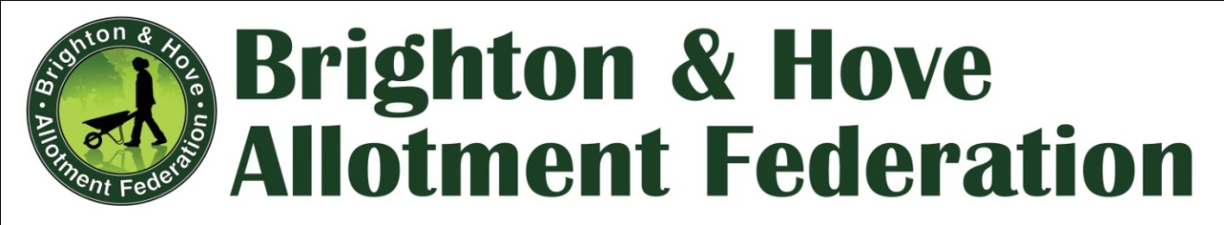

BHAF COMMITTEE MEETING (11th November 2015)

Robert Lodge, Whitehawk Road, BN2 5FG. 6.30pm

Present: Allan Brown (Chair), Hannes Froehlich (Treasurer), Mark Carroll (Publicity Officer), Richard Howard (Elections Officer), Bill Parslow (Secretary), Anne Glow (Bookings Secretary), Giuseppina Salamone (Plot Liaison Officer )
Committee Members: Maureen Winder, Jane Griffin

- Tenant disputes with council:
An appeal email received by the committee was referred back to the relevant site representatives in the first instance.
A previous appeal against an eviction has been stayed after the intervention of the Plot Liaison Office

- Rules revision

The revised rules, now published on the website are to be taken to the January forum. Giuseppina to make a small change to the probationary period and publish it to the site

- Site Rep - Roles and Responsibilities
- Very useful facilitated meetings have been taking place, and a further facilitated session will take place in the Food Partnership Offices at the Brighthelm Centre on Tuesday 1st December 2015. Any site representative can attend , but please contact the BHAF (bhaf.contact@gmail.com.) first so that any increase in numbers can be accommodated.

- Site Elections

Notices for the election of Site Representatves on November the 20th were put up at Foredown, Mile Oak, Campsite, St Louie’s Home and Lark Hill sites in October

In all cases, except Lark Hill, existing Site Representatives are up for election, and there have been no further nominations. Lark Hill is a very small site and no one is willing to stand as a Site Rep.

Richard is taking an area based approach will be visiting the Ovingdean, Rotting dean and Hillside sites next.

Agreed that while the election process is not encouraging more people to become Site Representatives it is raising the profile of those already existing.

- Development Fund

Applications:
- Wood chipper for Ovingdean, to manage their extensive hedges. - £719.00 AGREED, with the request that this wold be borrowable by other Site Reps. / Associations
- Coldean Allotments. A number of requests for enhancements to allow the use of an existing allotment communal building, and to maintain things like WC’s which are already there. The Committee agreed to refer this back to Coldean, as a number of the costs were not stated.
- Awaiting a substantial bid from The Moulsecoomb Allotment association to replace the crumbling asbestos roof on their association building.
- Apple Pruning – now 7 workshops booked in, with up to ten attendees at each, likely cost to BHAF of £75 per workshop.
- Toilet. St Louie Home. The Committee agreed to uphold our previous decision not to use the development fund for site toilets. It was decided that the ongoing upkeep of a site toilet would be problematic and expensive. Especially if every site decided they wanted one.
The right place for the liquid gold is on the compost pile where it acts as an activator! And a bucket in the shed should suffice as it always has done.

19 November 11am
Plot 22 Weald Allotments
21 November 11am
Roedale Valley
22 November 10am
Keston Allotments Patcham
6 December 11am
Tenantry Down Allotments
13 December 11am
WhiteHawk Hill
7 January
Camp Site Allotments
17 January Sunday 11am
Weald Allotments

- Wider Profile for BHAF in the light of more challenging times for allotment services
- Discussion as to how we might raise the profile of allotment gardening in a positive way, so that it is seen to be meeting worthwhile needs. This included:
- Workshops on everything form Compost making to Soil Improvement
- Making more of the link between allotment gardening and improved mental health – links with public health.
- Encouragement of development of recognition of allotments as havens for wildlife, birds, butterflies etc.
- Vox pop pictures / videos of people talking about their allotments, regularly up the website (perhaps buy a small video camera to facilitate this.
- Links to social media – set up an Instagram account for pictures (Bill to do)
- Next liaison meeting should include the lead councillor and other important influencers, to discuss the impact and continuance of the allotment strategy.
- Food Partnership “pop-up” allotments – how can they translate into people taking up allotments?
- Community Groups – greater profile for the part allotments play in supporting them, make links with BHAF

- Code of Conduct for Committee Members

Agreed that we need a more well defined constitution. Committee to look at the various papers already circulated, discuss at the next meeting

- Date of Next meetings:

BHAF Committee: Weds 27th January 2017 (Robert Lodge)

BHAF Forum: Weds 13th January 2016 – (Patcham) (Advance apologies from Bill whi will be away).

BHAF AGM : Thurs 16th March at the Brighthelm Centre

Meeting ended 8.50pm.

Bill Parslow

Secretary

