ANNUAL GENERAL MEETING

2016 Minutes

Weds 16th March 2015, 7.00pm.

Brighthelm Centre, North Road, Brighton, BN1 1YD.

Present.
Committee members:
Allan Brown, Mark Carroll, Bill Parslow, Anne Glow, Maureen Winder, Giuseppina Salamone, Richard Howard.

- Welcome:
Allan Brown welcomed all present to the AGM
2. Apologies:
Hannes Froelich, Jane Childs, Jeff Woods, Janet Ramsay, John Fursefield, Steve Lucas, Elizabeth Kemp

3. Minutes of the last meeting:
The minutes of the 2015AGM have been on the BHAF website for the last year. There were no objections raised and the minutes were voted through and approved.

4. Treasurers Report 2015/16 (Hannes Froelich)

The report was read by Mark Carroll

- BHAF Account

BHAF and site reps expenses: £1234

(includes communication related expenses, like our web hosting and

email facilities, poster printing and distribution, room rentals,

transport, postage and site rep mobile phone costs)

Initiatives for all plot holders: £900 (apple pruning and AGM speaker)

Initiative for new plot holders: £2500 (leaflet; we got £2500 grant => no cost)

Start balance £5739

End balance £6547

- Site Development Fund

This year we had £6000 allocated from the council for site
developments across Brighton and Hove. We used 99% (£5965)
on the following projects:

Site improvements (raised beds and tree pruning) at Peacock
Lane (£95)

Shredder for the Ovingdean site (£770)

New roof for the meeting room/store hut at the Moulsecoomb
site (£5100)

- Summary
Overall the finances of BHAF can be considered in very good shape. However expenses can vary year on year, and this year there were less meetings then last year (e.g. no strategy meetings), so things may change in future.

Hannes Fröhlich
(Treasurer BHAF)
5. Review of current year and a look to the year ahead

- Waiting List
Marck Carrol summarised the waiting list situation noting it was down by ten, so more or less the same as last year.

 | Total Lettable Plots | Total Vacancies | Waiting List
Nov. 2013 | 3102 | 411 | 1725
Dec 2014 | 3054 | 273 | 1192
March 2016 | 3042 | 203 | 1182

- Site Rep Elections
Richard Howard reported that site representative elections were being rolled out across the city.
BHAF Elections have now been held at;
Coldean,
Waverly Crescent,
Manton Road,
Camp Site,
Foredown,
St Louie Home,
Hildesland,
Hogg's Platt,
Mill Hill,
Ovingdean,
Eastbrook,
Roedale,
Moulsecoomb,
Whitehawk and Craven Vale

- Site Representative Focus Groups
Maureen Winder reported on the focus groups. These had been very successful, and the following areas explored (a full report can be seen on the BHAF website)

Workshop aims:

- Share experiences of the site rep role
- Consider what motivates people to take on the role
- Acknowledge some of the challenges of the site rep role
- Explore and clarify what the role entails and what is expected of
- site reps
- Feed into the development of a clear site rep role description
- Discuss the support and guidance site reps need
- Determine what site reps can expect and require to fulfil their role
effectively

- Rules Revision
A number of small group workshops had been organised to revise the allotment rules. The Chair remarked that on examination many of the current rules had a sensible rationale behind them, so the revised rules are just that – a revision and tweak of the existing rules. The revised rules have been available on our website for the last 5 months and the deadline for submissions and edits was February 16th 2016.

Progress had been shared on our website and by our email newsletter throughout, so the rules were put to the vote and passed by an over whelming majority (2 abstentions and one against)

- Biosphere, Butterfly Plots and Leaflets
Maureen Wilder reported on the meetings with partners across the city, where allotments were seen as an important part of maintain biodiversity corridors. The Chair also reported on highlights of the year and future projects.

It was mentioned that not mowing grass and nettles in some parts of your allotment will enable important butterfly habitats.

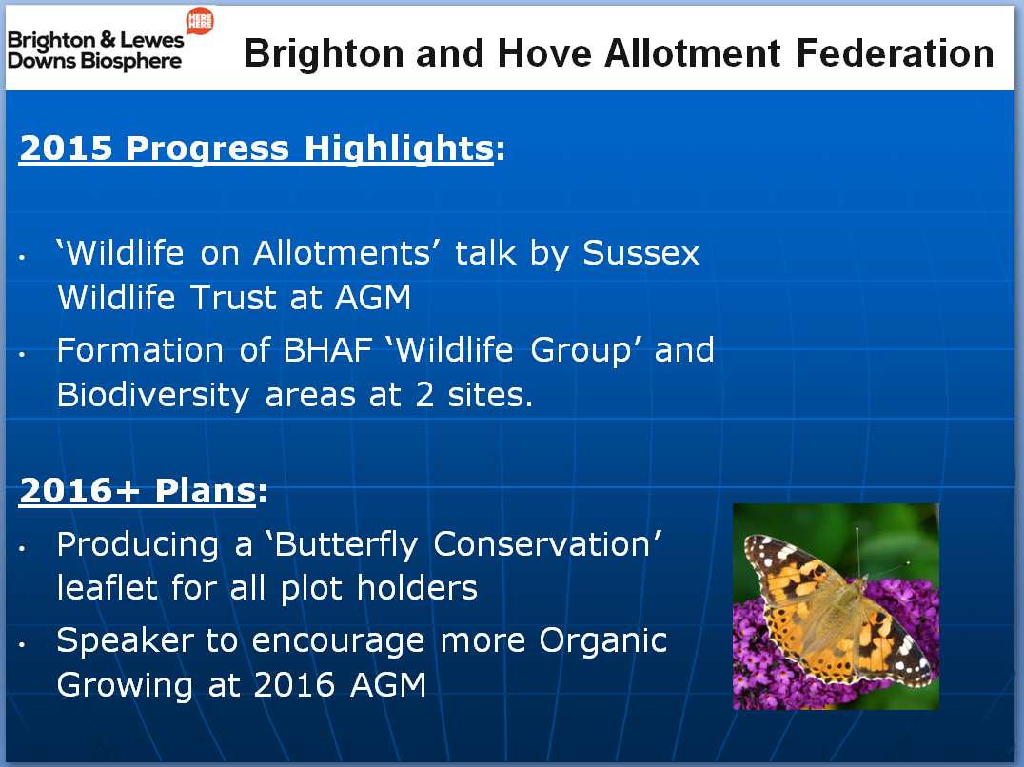

- New Starter Pack
Mark Carrol reported that a new starter pack, joint funded by the Food Partnership had been designed and printed for new allotment holders

6. Proposal: 'BHAF committee members should support the establishment of designated wildlife areas, where these are possible and that these should have the guarantee of protection in the long-term. To achieve this aim BHAF could ask for a review of the appropriate section of the B & H Allotment Strategy

From- From members of the Moulsecoomb Allotment and Horticultural Society Wildlife Group: Sally Griffin, Heather Ball, Liz Yeats, Jim Grozier, Sally McGregor, Rachel Cohen, Richard Howard, and Dave Witts “Promoting and protecting wildlife initiatives on allotment sites.”
They spoke to the motion hoping that, should an established wildlife site such as ours be threatened with being turned into allotments again, BHAF would support us in opposing this.

The motion was carried unanimously

7. Election of Officers and Committee:
All positions were to stay the same as last year and voted in on a block vote. The Committee is as follows:
President: Gerry Neville
Chairman: Allan Brown
Secretary: Bill Parslow
Treasurer: Hannes Froelich
Publicity Officer: Mark Carroll
Plot Holders Liaison Officer: Guispina Salamone
Site Reps Election Monitor: Richard Howard
Assistant Secretary, Events and Booking Co-ordinator: Anne Glow
BHAF Wildlife Group: Maureen Winder
Nominations for new committee members were voted on and accepted.
Committee Members:
Jane Griffin:
Jim Mayor

It was stressed that the BHAF is always in need of volunteers, either to sit on the Committee or to work on specific projects and any help would be greatly appreciated.
8. Short Interval:
Refreshments were served before and during the meeting. We had wine and cheese, tea, coffee and biscuits, soft drinks etc. This proved poplar!

9. – talk by Bob Flowerdew:
Bob Flowerdew gave a most entertaining and informative talk on organic gardening.

Thanks to all those who attended.

