Allotment forum
22.11.17 7pm
Council: cllr Lee Wares/Rob Walker/Bruce Riach
Fed: Mark Carroll Josephine Salamone Maoureen Winder Richard Howard Hannes Froelich
David Cooper away 3 months Replaced by Bruce Riach
Reducing deficit ideas
1/Overpayment for well off. People on low wages and Doctors all pay the same! Many people say they are willing to pay much more, many people say they are not able to pay more. Our idea is to have a 3 tier payment system. Full Wage/ Low Wage / Concessions
2/ Concessions opt out for people who do not need it
3/Pension Age bring in line with State Pension Age

Waiting List Fee
These figures show that the new waiting list fee is looking like it will bring in around £4000 per annum. It has reduced applications by about 50%. We will need to keep an eye on these figures to make sure that applications do not drop any lower.
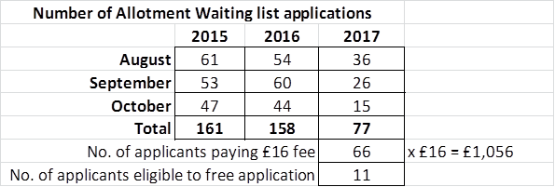

Introduction to the new Rules
In revising the Allotment Rules, a Committee formed by plotholders and members of the BHAF Committee decided to focus on the reasons for having rules and agreed to start from five principles:

1) use your plot,
2) respect your neighbours
3) respect the Site and the environment
4) respect yours and others’ health and safety and
5) pay the rent.

We then ordered basic main rules under these five principles.
‘Use your plot’, prescribes that most of the plot is used for cultivation, with ‘cultivation’ described broadly, allowing for a variety of gardening methods and aims.
‘Respect your neighbours’, includes a duty to control weeds that can cause disruption for the adjoining tenants’ gardening or to control the height of trees that can create shade on other plots.
‘Respect the Site and the environment’ would forbid bringing on site items or substances, or adopt practices, that can cause irreversible or long term damage to the plot.
'Respect yours and others’ health and safety' means the prohibition of hazardous items, structures or practices on the Site.
‘Pay the rent’ is self explanatory!

We also formalised the new Strategy’s principles about upgrading/downgrading plot sizes, as well as the current inspection and notification practice, to make sure that there is one rule for all Sites. Adopting the spirit of the Strategy, we have aimed at protecting disabled access and rights and we have also prescribed a fair and non discriminatory procedure in case of extenuating circumstances affecting tenants.
Development Fund
Mark Carroll appealed for applications for the development fund and suggested things for which it could be used for.

Free Compost Deliver via BHAF
Hannes discussed his project for the BHAF to buy and supply free compost to tenants on a one off basis. We have excess funds at the moment and the meeting thought this would be a good way of giving something back to plot holders. Especially those that are struggling financially.

Team Pollinate : Beth Nichols
Beth spoke briefly about the results that ‘Team Pollinate’ has produced. Beth will present these results at the BHAF AGM in March.
Rich Howarth Biosphere
Rich Howarth gave a presentation regarding the biosphere project and how allotments fit into the overall picture. It was an inspiring talk and many allotmenteers were made aware of how important allotments are in terms of the biodiversity of the city.

Meeting ended 9.00pm

