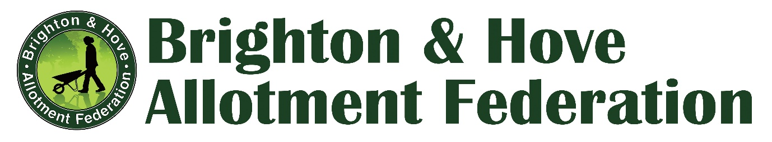
Brighton and Hove Allotment Federation (BHAF)
Annual General Meeting 6th April 2022

Minutes

Introduction
The Chair opened the meeting by welcoming everyone and thanking everyone for attending. He noted that this is the first AGM we have been able to hold in person since April 2019. (Due to Covid 19 Restrictions and Lockdowns)

Apologies
Simon Powell; Victoria Williams (BHAF Committee)
Rachel Chasseaud (BHCC)
A number of apologies were received from individual members unable to attend due to illness or or worry about Covid.

Chair’s report
Mark Carroll gave an extended briefing on the issues that have faced allotment holders, BHAF and the Allotments Service over the past two years. These include:

- Impact of Covid on services, particularly operational problems on the ground – lettings, maintenance etc.
- The problem of unused plots and overgrown plots as no eviction notices could be served due to suspension of inspections for two years. True figure for unused plots is almost certainly higher than officially recorded.
- Waiting list – at a historical high with around 2785 people on the list but still with around 250 vacant plots.
- Complete slowdown of lettings and significant problems with the letting’s procedures due to new GDPR restrictions. We currently have the slowest letting procedure at the same time as the highest waiting list.
- Progress on implementing the Allotment Strategy: Thanks particularly to very active and supportive Councillors on the Environment, Transport and Sustainability Committee, there has been progress here and BHAF is very grateful to these Councillors and to senior BHCC officials for making things happen. A liaison group is meeting regularly comprised of BHAF committee members with Paul Campbell (CityParks senior manager) and Beulah Knight (Projects Officer).
- Mark concluded with a big thank you to our site reps for all their hard work in keeping sites running over a very challenging period.
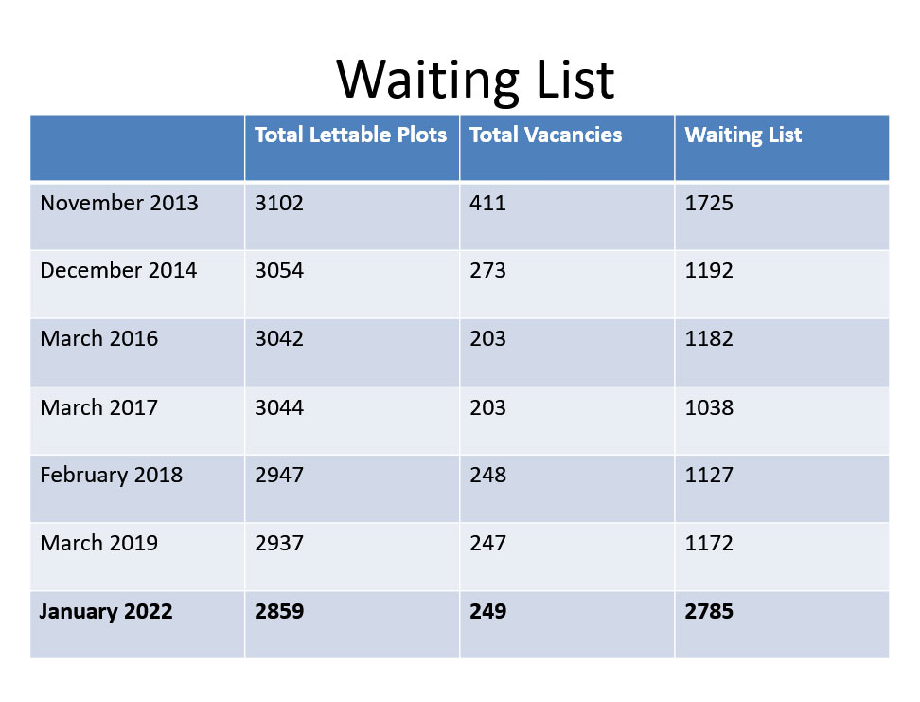

Treasurers report- BHAF Accounts and Development Fund
Expenditure from the Development Fund has been very low during the pandemic. Sites are encouraged to think about improvements that they can make that fit the fund criteria. An example was shown of a very innovative solar power project at Moulsecoomb which allotment holders can use to power batteries and other small devices.

This year we had £6000 allocated from the council for site developments across Brighton and Hove. We spent 15% of the fund.
  - Clearing green waste – Mile Oak (£300)
  - Solar PV setup – Moulsecoomb (£550)
Total £850

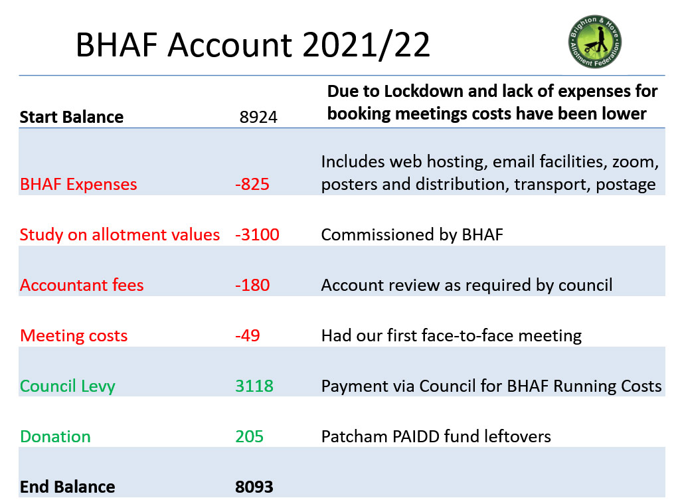

Election of Committee for 2022-23
All existing committee members presented themselves for re-election:
Mark Carroll, Hannes Froelich, Hilary Standing, Nick Fry, Allan Brown, Andrew Amos, Giuseppina Salamone, Maude Casey, Victoria Williams, Simon Powell.

A new nomination was received for Ronnie Mair, Windmill Hill. He was proposed by John Longthorn and seconded by Malcolm Gann (both Windmill Hill).

Re-election and election were done with a show of hands. There was one abstention (nature not specified) and no objections.

Strategy Update
Paul Campbell, City Parks Projects and Strategy Manager, gave an update on progress with implementing the 2014-24 city Allotment Strategy. He gave the background to this and reported on progress with resolving a number of operational issues at site level. He noted that of the 82 recommendations, around 24 are now actively being worked on. Some have been amalgamated, others were redundant. Paul also reported on work he has done to enable the use of Community Protection Notices (CPNs) on allotment sites in cases of harassment and other anti-social behaviour.

A question from the floor requested that updates on implementation be made available to plot holders.

Introduction to 'The Value of Allotments' Report
Jim Mayor, plot holder and principal author of our recently commissioned report on quantifying the value of allotments to the city, presented an overview of this work. He noted there has been a consistent narrative from the Council that allotments are a subsidised service. The study, which examined nutritional, health and wellbeing, and environmental benefits of allotments, challenges that understanding. It found that allotments save the Council significant amounts of money.
https://www.bhaf.org.uk/content/about/issues/the-financial-value-benefits-of-allotments

________________________________________

Panel Q&A Session 'The Future of our Allotments'
We were delighted to welcome a great panel of guests for our Q&A reflecting on the Value of Allotments report and the future of allotments in the city.

Panellists:
Councillor Jamie Lloyd (Green)
Councillor Nancy Platts (Labour)
Councillor Robert Nemeth (Conservative)
(Members of the Committee on Environment Transport and Sustainability)

Robert Walker
Paul Campbell
(City Parks)

Introductions:

Councillor Robert Nemeth - Bee Keeper at Weald and Craven Vale Secret Garden; long association with allotments - his wife has an allotment.

Councillor Nancy Platts – involved with Park Run in East Brighton Park; Park forum; Open spaces forum; committed to making outdoor spaces accessible and available to all; has an allotment but doesn’t grow anything: her partner does!

Councillor Jamie Lloyd – Deputy Chair, Committee on Environment Transport and Sustainability. His wife has just taken on an allotment share and he is learning about growing!

Question 1
If you could pick one finding from our report that you found particularly helpful as a decision maker, what would it be? And if you could have had one additional benefit included, what would it have been and why?

Robert Nemeth: The subsidy argument justifies the rent and encourages the council to put it up. We need to develop a robust defence of allotments so we can show how allotments are a better use of land than anything else

Nancy Platts: Admired the holistic nature of the BHAF Value of Benefits report – makes it easy for councillors to do their work especially on social capital – mental and physical benefits, accessibility and open to all – we shouldn’t view the world just through an economic lenses there are additional benefits: food miles and packaging; Can food for big local organisations be grown locally?

Jamie Lloyd: hates plastic waste, allotments show diversity benefits and major benefits for wildlife. Growing our own food is ever more crucial for geopolitical reasons – there’s lots of unused green space which could be opened up for community growing and for allotments.

Robert Walker: carbon sequestration possibilities – it’s commonly perceived that cultivated land is poor on carbon sequestration whereas the opposite is the case. Big reduction in domestic green waste if all allotmenteers are taking theirs and maybe also even their neighbours’, to compost on their allotments

Questions 2/3/4
What is the biggest barrier to unlocking benefits?
As a councillor, what do you see as the biggest barrier preventing allotments from reaching their potential at a local level? How can we unlock more of the benefits?
Given the mental and physical benefits of allotments, highlighted in the report, from your perspective what changes are needed to facilitate contributions from health budgets to take advantage of these benefits to improve health and wellbeing across the city?
With over 2500 people on the waiting list and many lists now closed, do you think we have enough allotments? Is it acceptable to operate with approximately 250 plots vacant at any one time? Do you see any scope for expanding the availability of allotments across the city?
Robert Nemeth- The costs lie with city parks – but in view of Jim’s report should mental health be contributing to allotments too?
Also having 10% of plots not let is ridiculous – they should have 100% occupancy – he owns garages and his rate of letting is 100% let. Also, the Council should be tidying everything up – it can’t have messy paths and car parks while also telling allotmenteers to tidy up their own paths. Allotmenteers should be seen as a loss leader so that they are given a helping hand to get started.

Nancy Platts: The GDPR data protection rules were a block. Space is also a blockage, so think about starter plots. On the health budgets issue – there is money from NHS social prescribing purposes; there are also pockets of money for this, eg for young offenders and for linking up allotments with funding for social benefits to other parts of the community.

Jamie Lloyd: Communication was not good for many years and this was the biggest blockage to progress but now thanks to recommendations from BHAF this is improving; to help with this we could have open days to provide something to people even if they don’t have an allotment of their own; also funding could be diverted from public health – for example for the Active Travel Initiative they get funding pots from health rather than department of transport.

Robert Walker: Communication has been a big blockage, hopefully now easing. The available land is on the margins of the city rather than in the centre. So people driving to allotments defeats the purpose.
In the course of his career, he has seen the demand for allotments grow, shrink, and grow again. Currently it is on the increase as never before. With a waiting list of 2,500. The challenge now is to find more land. So, how can we use the green spaces in the centre? On verges and around blocks of flats? We could have strategic periphery planning; community growing is already happening on eg the BHOGG community plot - could this be done on more designated specific plots?

Paul Campbell: Efficiency in urban design is key – we are hemmed in by sea and downs – so every square metre must be used as efficiently as possible – path size should be standardised, so should shed size and design; plot area should be standardised; rainwater harvesting must be tackled. He recently returned from Switzerland and was impressed by the Swiss efficiency in the allotments he saw. Is shocked by the number of plots here where fruit is dropping onto the ground. Why not get the primary schools in to harvest this?

These comments and audience questions prompted a lively and well-informed debate:
- People questioned this mechanistic definition of ‘efficiency’ and enthusiastically championed biodiversity, wildflowers, and edge gardening for pollinators
- As mentioned in the Value of Allotments report, a study of the biodiversity of different types of land in the UK found that allotments were the most diverse – even above the countryside.
- The importance of using all edges, urban spaces and borders for wildlife was emphasised.
- Growing flowers and having wild life habitats on allotments also really important as well as vegetables.
- People suggested reducing the time people are given to decide they don’t want an allotment after all, from one year to six months.
- Importance of offering help to fellow plot-holders who appear to be struggling.
- Given the stasis of the last few years, Paul argued it is important to get right the care of the land the service is currently responsible for, before actively taking on responsibility for more.
- The 2013 survey for the Allotment Strategy found that 50% of plot-holders live within ten mins of their allotments; 30% within 20 minutes; 2% within 30 minutes.
- Wildlife is key – if you intensify growing, you can increase veg yields and lettings, but also cause reduction in wildlife
- Councillors said: If there’s demand, we can provide. Volunteer groups have already done so much – let’s involve people rather than trying to control them.
- Community growing could be done using a different set of rules that are more appropriate to this.

Final comments

Jamie Lloyd: Let’s get the service working again! We do need more space for growing – so let’s appreciate our ‘dead green land’ eg around flats and on verges.

Nancy Platts: Going out into the open air benefits mental health and physical health – gives energy to grow the mind and body as well as plants.

Robert Nemeth: Use of Section 106 and tap into biodiversity rules – developers are supposed to show how their projects provide net gains in terms of biodiversity and they must give funds for this. We could ask the Council to pool these contributions together as a ring-fenced fund. If the funds aren’t used for allotments they will go elsewhere.

Paul Campbell: Importance of allotments in linking into the city’s wildlife corridors, for example Roedale and Saunders Park, but also verges and railway tracks. These all need to be linked up – the pieces are there but they need to be brought together.

The moderator thanked the panel and they were given an enthusiastic round of applause. The Chair closed the meeting by thanking everyone for attending.

The meeting concluded at 9.15 pm.

