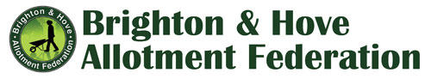
CODE OF CONDUCT - BHAF COMMITTEE MEMBERS

On election to the BHAF Committee, members agree to:

Support and work towards BHAF’s primary aim of achieving the goals of the Brighton and Hove Allotments Strategy, representing the interests of its members.

Support BHAF in upholding the principles of inclusion and diversity and ensuring that no member is discriminated against on the basis of race/ethnicity, gender, sexual orientation or religion.

Declare or draw attention to any potential conflicts of interest that may arise in attending a committee meeting or in acting on behalf of BHAF.

Engage constructively and respectfully in committee discussions, listen carefully, challenge sensitively and avoid conflict.

Respect committee and individual confidentiality, and not share internal discussions with outside parties without authorisation from the Chair – while not using confidentiality as an excuse to avoid disclosing matters that should be transparent and open.

Fulfil any responsibilities assigned at committee meetings and report back regularly on progress.

Raise any concerns or grievances in the first instance with the Chair.

