Benefits of having an allotment responses from the plot holders survey 2013

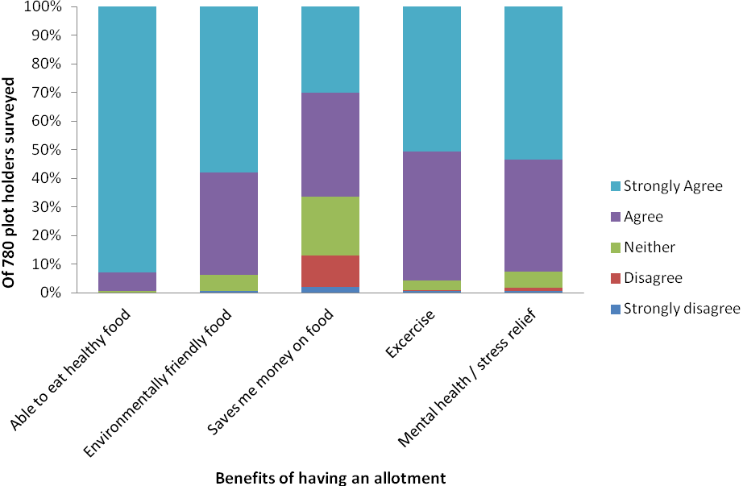The survey also asked plot holders to rate their overall health and their perception of the impact of their allotment on their health and happiness. People viewed their allotment as having a powerful impact on their overall health and happiness with 74% giving this a score of 8 or more out of 10.

The majority of allotmenteers from the survey say that having an allotment is about access to healthy and sustainable food but 80% also feel that allotments benefit their mental health, 95% say it is good exercise and 72% say they feel part of a community.

Plot holders reported (free text comments and consultation events) that whilst saving money overall may not be the main benefit; an allotment did allow them to make food choices (e.g. organic or healthier food) that they wouldn’t otherwise have been able to. The younger age groups tend to see growing food with low environmental impact as a particular benefit.

A striking difference in terms of the seven benefits listed was that people with disabilities saw greater benefit for all seven compared to those people without disabilities. The main differences were seen in terms of saving money on food bills, being more aware of nature and the environment, improving mental health and general exercise.

In comparisons across the employment groups it appears that unemployed people perceived greater benefits than employed people in particular for accessing healthy food, saving money, mental health and general exercise. The highest rating for the benefit being saving money came from unemployed people. Retired people and carers reported high benefits in terms of socialising and general exercise.

Access to food grown yourself
As defined by the Allotments Act of 1922 allotments are wholly or mainly cultivated for the production of vegetables or fruit crops. A plot in Brighton & Hove can also be used for growing flowers or as a leisure area as defined by the allotment rules for the city.

The plot holder survey asked people what they use their plot for
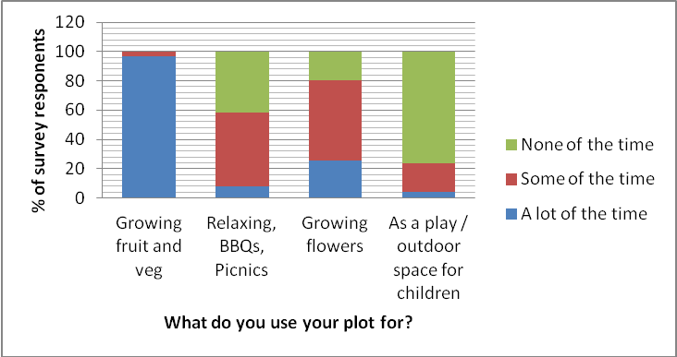
The survey also asked people what proportion their fruit and veg consumption came from their plot. It can be seen that of the plot holders in the survey (77%) get less than half of their fruit and veg from their plot.
Averaging it out over the year what proportion of your fruit and vegetable consumption comes from your plot?
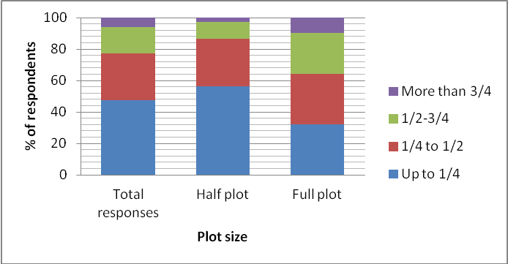
Not surprisingly given the smaller amount of land those on half plots generally report a lower proportion (56% said less than ¼ compared to 32% of those on a full plot). However an average fruit and veg consumption per day per person in the UK is 258g so this is still a significant amount of food being produced on allotment land in the city. Further research here may be helpful.
When compared back to the seven general benefits, those who reported increased levels of fruit and veg consumption provided by their plot were also more likely to report increased benefits in terms of eating healthily, growing food with low environmental impact and saving money on food bills. Therefore those that grow a greater proportion of their food gain greater benefits.
Interestingly, there was no difference in improving mental health or stress release according to the proportion of fruit and veg consumption provided by the plot. This particular benefit was seemingly universal for all allotmenteers, regardless of how much of their fruit and veg consumption was provided by their allotment.

Health and Mental Health Benefits
Those answering the plot holders survey (n=787) were asked to rate their overall health. The same question was asked in the 2012 health counts survey

In general would you say your health is

From this it can be seen that in general allotmenteers say they have better health than the general population.
Allotmenteers were asked to consider the extent to which having an allotment is an important factor in their health and happiness (on a scale of 1-10 with 10 being the highest). 90% of plot holders surveyed believed that allotments were important to their health (range 7 to 10) and a remarkable 42% gave this figure a top rating of 10. More women reported that having an allotment was an important factor in their health and happiness than men and the older age groups especially agreed that the allotment contributes to their overall health and happiness.
Unemployed people rated their health as the poorest of all employment groups, although they provided one of the highest ratings for the allotment acting as an important factor in their health and happiness. In general, people with a disability provided a lower score for their overall health – 50% rated it as fair or poor relative to 4.1% of those not having a disability.
Those with a disability saw the allotment as a means of contributing to their overall health and happiness to a greater extent to those without a disability. Clearly, having an allotment plays a valuable role in people’s health and happiness, particularly for those people with disabilities and unemployed people.
It would not be possible for me to put a price on the significance that having an allotment has had for me in terms of improvement to my physical and mental well-being. I am able to harvest a small but reasonably sized amount of produce from my small half plot-all delicious of-course! But the primary benefits are social and spiritual. I can't imagine my life now, without having an allotment – Plot holders survey response

Healthy diets and exercise
A very significant number of plot holders agreed or strongly agreed with the statements that a benefit of having an allotment was to eat healthy food (98%) or for general exercise (96%).
Obesity is estimated to have cost the NHS in Brighton & Hove £78.1 million in 2010. York University state that the cost of Diabetes is approximately £23.7 billion with direct and indirect costs in the UK in 2010/11. Locally, the Clinical Commissioning Group (NHS Brighton & Hove) spent £3.1 million on prescriptions for Diabetes items between April 2012 and March 2013, which is equivalent to £302 per adult with diabetes.
Forms of Diabetes are preventable through the consumption of good food and undertaking healthy exercise. NICE guidance emphasises local action to promote a healthy diet and physical activity among communities at high risk.
Mental health and wellbeing
In England, mental health conditions cost approximately £105 billion a year, due to loss of earnings and associated treatment and welfare costs. Up to one person in four experience some form of mental health illness in their lifetime.
92% of survey responses from plot holders agreed or strongly agreed with the statements that a benefit of having an allotment was to improve mental health / provide stress relief
Factors that are known to support emotional wellbeing have been developed by the New Economics Foundation into ‘Five Ways’ based on five simple messages about what helps to maintain positive mental health
Connect – Be active – Take notice – Keep learning – Give

Allotments provide an ideal setting to take part in activities that maintain positive mental health as can be seen by the survey results.

From the plot holders survey:
- 701 people agreed or strongly agreed that having an allotment made them more aware of nature and the environment
- 590 felt they were good places to meet a socialise with people of different ages and backgrounds
- 779 people agreed or strongly agreed that their site was a friendly place
- 562 agreed or strongly agreed that they felt they belonged to a community on their site.

“My allotment is the only reason I leave my flat. If it were not for my plot I would vegetate indoors” Plot holders survey

http://www.eufic.org/article/en/expid/Fruit-vegetable-consumption-Europe/
http://www.bhlis.org/surveys
mean score of 9.19 versus 8.44
NHS Brighton & Hove Public Health Directorate (2011)
York Health Economic Consortium Report, Journal of Diabetes Medicine (2012)
Diabetes Community Health Profiles 2012/13 developed by Yorkshire and Humberside Health Intelligence.
http://guidance.nice.org.uk/PH35
Centre for Mental Health 2010

